Paper title
Jan Kowalski¹, Aleksander Nowak²
¹ University of Warsaw, Warsaw
² Gdansk University of Technology, Gdansk, Poland
E-mail (email address of the main author for correspondence)
Abstract. Abstract text.
Keywords: five keywords separated with commas
- Chapter title (level 1)
The first paragraph under the title has no indentation. (Style: Bodytext style).
Subsequent paragraphs are indented (style: BodytextIndented style).
- Next chapter (level 1)
The first paragraph under the title has no indentation. (Style: Bodytext style).
Subsequent paragraphs are indented (style: BodytextIndented style).
  - Sub-chapter title (level 2)
The first paragraph under the title has no indentation. (Style: Bodytext style).
Subsequent paragraphs are indented (style: BodytextIndented style).
    - Sub-chapter title
The first paragraph under the title has no indentation. (Style: Bodytext style).
Subsequent paragraphs are indented (style: BodytextIndented style).
- Tables and figures
Tables and figures should be placed in the text close to where they are first referred to. Tables and figures should be numbered. Alignment to the center with signature.
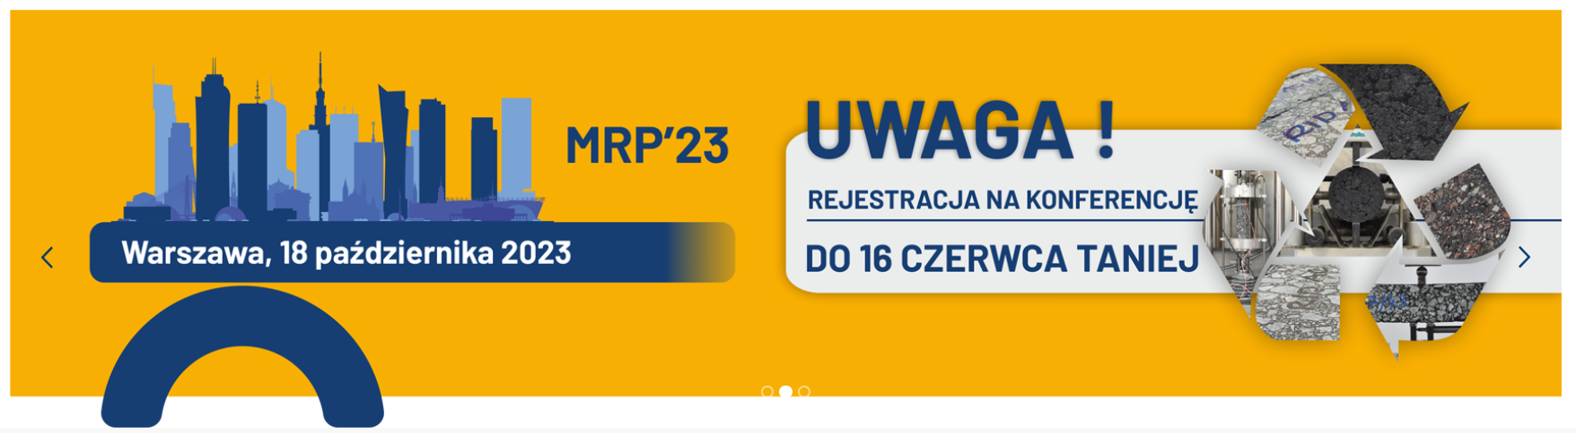
Figure 1. Example signature
- Bullet points
Please use the following bullet points:
- line 1, (style: Bulleted)
- line 2.
Literature (numbered in order of appearance in the text)
- Kukielka J., Bańkowski W., 2019. The experimental study of mineral-cement-emulsion mixtures with rubber powder addition. Construction and Building Materials, 226, 759–766. https://doi.org/10.1016/j.conbuildmat.2019.07.276
- Szydło A., Mackiewicz P., Skotnicki Ł., Kuźniewski J., 2019. Ocena wpływu innowacyjnego środka wiążącego na właściwości fizyczne, mechaniczne i reologiczne recyklowanej podbudowy wykonanej z mieszanki mineralno-spoiwowej z emulsją asfaltową. Report No. 3/2/PWr/2019. Program „Nowoczesne technologie materiałowe” TECHMATSTRATEG.
- Dołżycki B., Jaczewski M., Szydłowski C., Bańkowski W., Gajewski M. D.: Analysis of selected mechanical properties of mineral-cement-emulsion mixtures (MCE). Roads and Bridges - Drogi i Mosty, 22, 1, 2023, 41-61, http://dx.doi.org/10.7409/rabdim.023.003
Comment:
Authors of papers qualified for publication in the “Roads and Bridges – Drogi i Mosty” quarterly journal will be asked to adapt the paper to the editorial requirements of this journal (https://www.rabdim.pl/index.php/rb).

